NELSON OGODO

asset log

Asset Log

Asset Name | Purpose of the Asset | Link | Date Retrieved
Honey Image 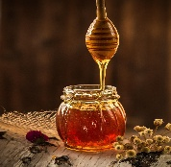 | This is a product image for Organic Honey listing | https://pixabay.com/images/search/natural%20honey/ | 22/04/2026
Eggs Image  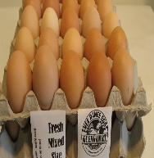 | This is a product image for Free-range Eggs listing | https://freerangeeggs.nz/ | 22/04/2026
Strawberry Image  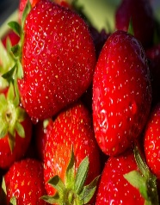 | This is a product image for Strawberries listing | https://www.freepik.com/premium-photo/red-strawberries_2149969.htm | 22/04/2026
Chicken Image  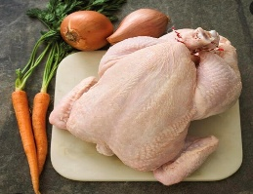 | This is a product image for Free-range Chicken listing | https://boylesbutchers.ie/shop/free-range-chicken/ | 22/04/2026
Fresh Milk Image  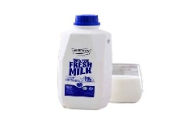 | This is a product image for Fresh Milk listing | https://www.mbizmarket.co.id/catalog/detail/fresh-milk-3938520-7057419.html | 22/04/2026
Carrots Image  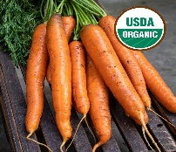 | This is a product image for Organic Carrots listing | https://purelineseed.com/certified-organic/ | 22/04/2026
Potatoes Image  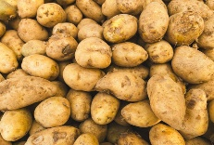 | This is a product image for Potatoes listing | https://www.istockphoto.com/photos/asian-market-above | 22/04/2026
Blueberries Image  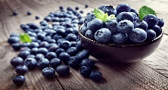 | This is a product image for Blueberries listing | https://wallpaperaccess.com/berry | 22/04/2026
Pork Image  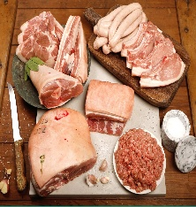 | This is a product image for Pork listing | https://shop.green-connect.com.au/products/free-range-meat-mixed-pork-packs-Pork | 22/04/2026
Lettuce Image  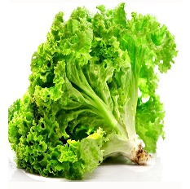 | This is a product image for Organic Lettuce listing | https://www.biophap.com/product/organic-lettuce-1kg/ | 22/04/2026
Bootstrap 5 | This is a CSS/JS framework used for responsive layout, navbar, offcanvas sidebar and dropdowns | https://getbootstrap.com | 20/04/2026
Inter Font | This is a primary font used across all pages as specified in the design documents | https://fonts.google.com/specimen/Inter | 20/04/2026
Web Speech API | This is a used to implement the Text to Speech accessibility feature | https://developer.mozilla.org/en-US/docs/Web/API/SpeechSynthesisUtterance | 22/04/2026
ASP.NET Core Docs | This is a reference documentation used for MVC, Identity and Entity Framework implementation | https://learn.microsoft.com/en-us/aspnet/core/ | 20/04/2026
EmailJS | This is a referenced for making the Contact Us form functional without a backend mail server | https://emailjs.com | 23/04/2026

